WIDE AREA NETWORKS
Tasks
1. Draw a simple diagram (on paper or using an online tool like draw.io) showing how your phone connects to Instagram's servers from your home WiFi, including the ISP and at least two Wide Area Network (WAN) devices (like routers or switches) in the path.
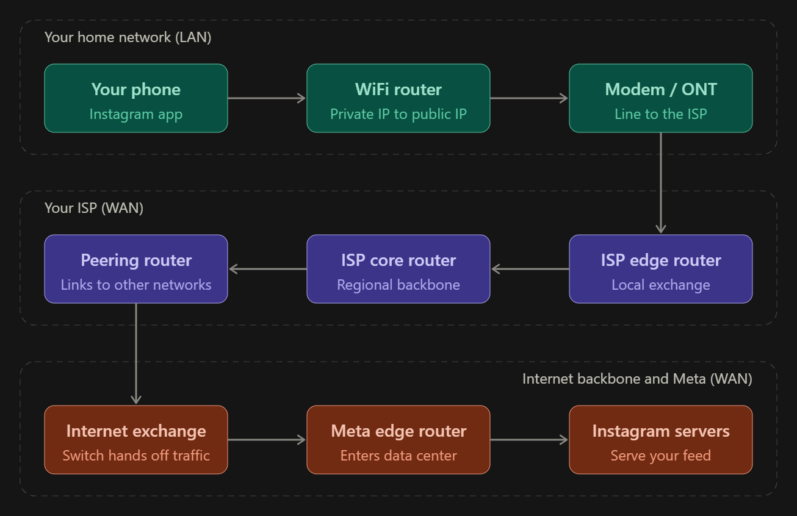
The diagram follows one request from your phone to Instagram. Read it left to right on the first row, right to left on the second, then left to right again on the third.
The path
- Phone → WiFi router. Your phone sends the request over WiFi to your home router, which does NAT (the same idea as your previous task).
- Modem / ONT. This converts the signal for your ISP’s line (fibre or cable).
- ISP edge router (WAN device 1). This is the first ISP device your traffic reaches.
- ISP core router (WAN device 2). It moves traffic across the ISP’s regional backbone.
- Peering router (WAN device 3). It connects your ISP to other networks.
- Internet exchange. A big switch where networks hand traffic to each other.
- Meta edge router and Instagram servers. The request enters Meta’s data center and reaches the servers that serve your feed. The reply returns along the same kind of path.
Where the WAN devices sit: the ISP edge, core and peering routers, plus the internet exchange and Meta’s edge router, are all WAN devices. That’s more than the two you need. If you want to keep it simple, you can draw only the ISP edge router and ISP core router.

2. Create a table listing three types of WAN technologies (such as MPLS, Leased Line, and Broadband Internet) and compare them based on speed, cost, and where you might see them used in real life (e.g., Zomato office, IRCTC ticketing, your home).

Comparison Table of 3 WAN Technologies
WAN Technology | Speed | Cost | Real-World Use Case Example
1. Broadband Internet | Medium to High (Variable speeds via FTTH/Cable) | Low to Moderate (Affordable consumer pricing) | Residential households connecting to online services like Zomato or YouTube.
2. Leased Line (P2P) | High, Dedicated, and Symmetric (Constant speed) | Very High (Expensive monthly enterprise subscription) | Connecting high-security bank branches or central database hubs.
3. MPLS (Multiprotocol Label Switching) | High and Predictable (Optimized routing) | High (Costlier than standard broadband) | Enterprise inter-office connectivity for ticket booking and reservation networks like IRCTC.

3. Research and write a short explanation of how a VPN (Virtual Private Network) uses WANs to let you access apps like Spotify or YouTube securely from a public WiFi at a coffee shop. Focus on how the VPN creates a private tunnel over the public WAN.

Explanation of VPN over WAN
A VPN (Virtual Private Network) secures data on public WANs by establishing an encrypted "tunnel" between your device (at a coffee shop) and a VPN server.
- How it works over WAN: When you access apps like Spotify or YouTube on public Wi-Fi, the VPN encapsulates your data packets inside encrypted wrapper packets.
- Security Benefit: Even though the packets travel across insecure public ISP routers and Wi-Fi access points, any eavesdropper or attacker can only see encrypted gibberish, preventing man-in-the-middle data theft.

4. Imagine Flipkart wants to connect its warehouses in Ahmedabad, Mumbai, and Delhi. Suggest which WAN technology would be best for them and justify your answer with two reasons.

Best WAN Technology for Flipkart Warehouses (Ahmedabad, Mumbai, Delhi)
- Recommended WAN Technology: MPLS (Multiprotocol Label Switching) or SD-WAN (Software-Defined WAN) built over enterprise-grade connections.
- Justification (Two Reasons):
  - Guaranteed Low Latency & High Reliability: Flipkart warehouses require real-time synchronization of inventory levels, order fulfillment, and billing databases across major hubs (Ahmedabad, Mumbai, Delhi). MPLS/SD-WAN ensures predictable packet delivery without public internet congestion delays.
  - Enterprise-Grade Security & QoS: These technologies provide private, closed network routing that protects sensitive logistics data, customer shipping details, and corporate communications from public internet exposure while prioritizing critical supply-chain traffic.

